Recommendation for Big mountain Resort on the basis of data analysis

1) Based on the below figure which is a correlation heat map of all features.
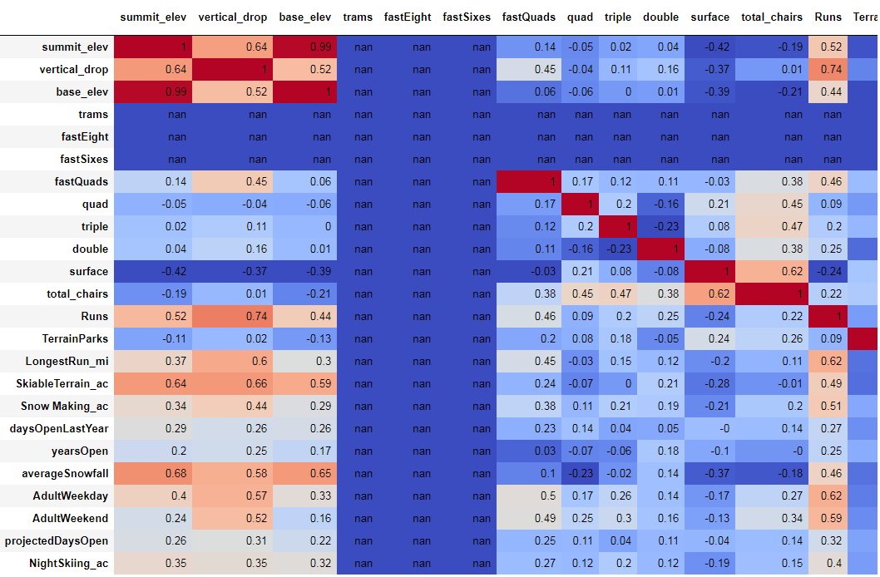
Following recommendations are suggested.
- Number of runs are highly affected by Vertical drop. To increase more foot fall height of vertical drop should be increased in the resorts having low vertical drop.

- Number of runs are affected by yearsOpen, Terrain Parks and Summit elevation. We can conclude that the old parks are having better footfall the new ones. WE should first priorities the increase of Vertical drop, Summit elevation and Terrain parks in newer parks to achieve better footfall in those.

- WE should be also focusing on increasing the number of days open per year to achieve greater footfall.

- We should be also focusing on increasing the longest run in the newer parks.

- Fast Quads seems to be an popular options. It is recommended to increase the frequency of the fast quad wherever it is available

2) Based on the relation between number of runs and Price of Adult weekend

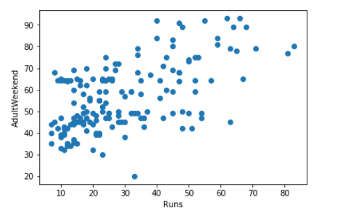

- It’s been observed that, In the resorts where number of runs are low, ticket prices are kept really low. It’s recommended to increase the price of the resorts where its has been kept very low. I.e for the resorts which has run between 10-20, we can fix the prices to 45-50. It would affext approximately 30 resorts.

- The Adult weekend prices of resorts with runs between 20- 50 are scattered. It would be beneficial if we could have them in the range of 55-70

- Resorts with higher runs then 50 should have the ticket price of 70 above where ever possible.

